CEE 532 – Developing Software Engineering Applications

*Project 3 – Frame Analysis*

MichaelJustice

11/23/15

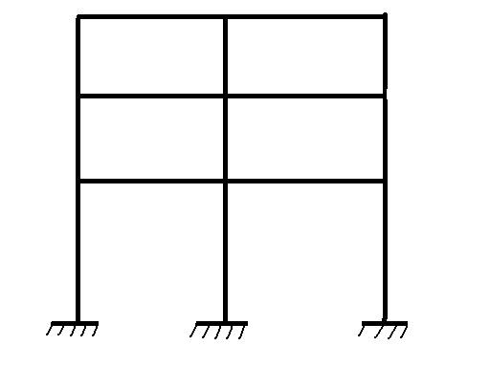

Contents

The Theory (A Succinct Summary) 2

The Input File 3

Test Cases 5

Test Case 1 5

Test Case 2 8

Test Case 3 11

Test Case 4 14

Test Case 5 17

Test Case 6 20

Test Case 7 23

Test Case 8 27

# The Theory (A Succinct Summary)

One of the most formal and common methods of performing a static frame analysis is the direct stiffness method. Using this method, any element loads that are applied to the frame are converted into ‘equivalent nodal loads’ so that Hook’s Law can be utilized to solve for the displacements at the nodes, (and all eventual quantities are then derived from the known displacements). As we’ve seen before, we can *directly* relate the stiffness of the elements with the forces applied at the nodes as shown below.

$KD=F$

Where **K** is the stiffness matrix of the element (or system) containing the material properties. The stiffness matrix is constructed by implementing the stiffness coefficients from the slope deflection method for a beam-column element (axial and flexural effects). The resulting stiffness coefficients for a beam-column can be organized for each degree of freedom at the node (lateral, transverse and rotational displacement). Using direct stiffness method, the displacements at the nodes can be solved for by using a matrix algebra.

The force vector **F** is a superposition of the nodal loads of the structure. Essentially, the equivalent nodal loads (which are calculated using the equations from the slope-deflection method) are transformed onto the global coordinate system so as to be *added* to the global nodal loads, and thus forming **F**. With **F** and **K** both known, the nodal displacements (or degrees-of-freedom) of the system can be solved for using one of many solving techniques for the general Ax=b matrix algebraic equation. The most effective method for solving the displacements is through the use of Cholesky Decomposition.

Once the displacements of the nodes of the structure are known, the forces at the nodes of the elements (axial, shear and moment) can be determined by then taking the product of the element’s stiffness matrix and displacement vector and subtracting out the equivalent nodal forces. The result is the forces at the ends of the elements due to the original loadings of the entire structure. With the forces known at the nodes, the method of equilibrium can be used to determine the axial, shear and moment at any point along the element. Using this method and the element properties, the subsequent flexure and axial stresses, as well as shear stresses, can be computed.

# The Input File

In order to analyze a particular frame under a given loading condition, the parameters of the frame (and its loading) must be properly implemented into the input file to produce the desired output. Shown below is each line of the input file and what belongs below that respected line.

1. *Heading – Below this line belongs the name of the problem, i.e. “Planar Frame (Units: [N, m])”. A string of text must be inputted here for this line to properly parse.
2. Nodal Coordinates – This is where the node number, x-coordinate and y-coordinate are placed. The nodes do not necessarily have to be in order for proper parsing of the input file.
3. Nodal Fixity – This input requires the node number and its respected fixity i.e. fixed in the y-direction, free in the x and z-direction. A specified displacement for the node other than zero can be placed here. Nodes can either have a specified displacement or be completely free to move in any direction.
4. Nodal Loads – The nodal loads of the system are specified here. Nodal loads such as concentrated x, y forces as well as concentrated moments can be applied at any node of the structure. The program will produce an error message if a duplicate nodal load is inputted.
5. Material Data – The material data such as elastic modulus (Young’s Modulus), Poisson’s ratio and the coefficient of thermal expansion can be specified here in groups. Improper material constants will produce an intentional error message.
6. Cross-Sectional Data – The cross-section type and the associated dimensions can be specified here in groups. This program supports the use of three different cross-sections: rectangular solid, circular solid and wide-flange symmetric sections (ala ‘I-sections’). Improper cross-sectional dimensions or types will produce an intentional error message.
7. Element Data –The element number and its associated start and end node are prescribed here, as well as the material and cross-section group tag for the respected element.
8. Element Loads – This is where the element loads are specified, such as a concentrated x and y-direction load, concentrated moment and distributed loads. The former three types of loads are prescribed by inputting the location of the loads along the element (distance from start node of the respected element) and the magnitude (and direction) of the load. The distributed load is prescribed by inputting the intensities of the load at the start and end node. Proper checks of the element loads along the element are carried out i.e. distance from start node is less than zero, greater than length of element, and signs of the intensities of the distributed load must be identical. Duplicate data is not checked as the element loads are superimposed over the element.
9. *end – This signifies the end of the input file. This string “*end” is needed for proper parsing of the input file into the program.

Below is an example of a proper input file that is to be parsed and read into the program.

|  |
| --- |
| *heading  Planar Frame (Units: N, m)  *nodal coordinates  ** Node #, x-coor, y-coor  1 0.0 0.0  2 0.0 10.0  3 5.0 10.0  *nodal fixity  ** Node #, x-fixity, y-fixity, z-fixity, x-disp, y-disp, z-disp  1 specified specified specified 0.0 0.0 -0.01  3 specified specified specified 0.0 0.0 0.0  *nodal loads  ** Node #, x-force, y-force, z-moment  2 0.0, -10000.0, -100.0  *material data  ** MAT #, E, v, CTE  1 2.2e10, 0.3, 1.1e-5  2 4e10, 0.3, 1.1e-5  *cross-sectional data  ** X/S #, type, list of values  1 rects 1 1.5  2 circs 0.1  *element data  ** ELE #, SN, EN, MAT #, X/S #  1 1 2 2 1  2 2 3 1 2  *element loads  ** ElE #, Load type, value 1, value 2  1 dly' -5000.0 -2000.0  2 ploady' 3.0 -5000.0  2 ploady' 2.0 -5000.0  2 ploadx' 2.0 3000.0  2 cmoment 1.0 100.0  1 dly' -1000.0 -1000.0  1 ploady' 5.0 -2000.0  *end |

# Test Cases

## Test Case 1

*UNITS: [N,m]*

The first test case involves a two-element system, both oriented along the x-direction. The model is as shown below.

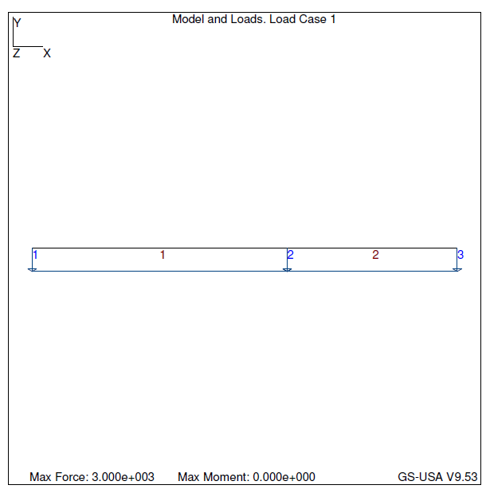

The table for the test case is as shown below. Note that for the remaining test cases, the model will be shown first, followed by the result table.

Test Case 1 – Input

|  |
| --- |
| PROBLEM SIZE  ------------  Number of nodes : 3  Number of elements : 2  Number of Material Groups : 1  Number of Element Property Groups : 1  Length of all members : 10  Number of Effective DOF : 2  ELEMENT MATERIAL PROPERTIES  ------------------------------------------------  Element Young's Modulus Poisson's Ratio CTE  ------------------------------------------------  1 4e+010 0.3 1.2  2 4e+010 0.3 1.2  ELEMENT CROSS-SECTIONAL PROPERTIES  -------------------------------------------------------------------------------------  Element Type Area Moment of Inertia Shear Factor Section Modulus  -------------------------------------------------------------------------------------  1 Rectangular Solid 0.125 0.00260417 0.0833333 0.0104167  2 Rectangular Solid 0.125 0.00260417 0.0833333 0.0104167  NODAL INFORMATION: COORDINATES  ---------------------------------------  Node X-Coordinate Y-Coordinate  ---------------------------------------  1 0 0  2 6 0  3 10 0  NODAL INFORMATION: FIXITIES  -------------------------------------------------------------------------------------------  Node X-Fixity X-Disp Y-Fixity Y-Disp Z-Fixity Z-Rot  -------------------------------------------------------------------------------------------  1 Specified 0 Specified 0 Specified 0  2 Free Specified 0 Free  3 Specified 0 Specified 0 Specified 0  ELEMENT INFORMATION  ----------------------------------------------  Element Start Node End Node Length  ----------------------------------------------  1 2 1 6  2 3 2 4  NODAL LOADS  ------------------------------------------  Node X-Force Y-Force Z-Moment  ------------------------------------------  ELEMENT CONCENTRATED LOADS  -----------------------------------------------------------------  Element Load Type Dist from Start Node Load Intensity  -----------------------------------------------------------------  ELEMENT DISTRIBUTED LOADS  -----------------------------------------------------------------  Element Load Type Int at Start Node Int at End Node  -----------------------------------------------------------------  1 LOCAL Y -3000 -3000  2 LOCAL Y -3000 -3000 |

Test Case 1 – Output

|  |
| --- |
| ====================== FE RESULTS ======================  NODAL DISPLACEMENTS  --------------------------------------------------------  Node X-Displacement Y-Displacement Z-Rotation  --------------------------------------------------------  1 0 0 0  2 0 0 2.88e-005  3 0 0 0  ELEMENT NODAL FORCES  --------------------------------------------------------  Element Axial Force Shear Force Bending Moment  --------------------------------------------------------  1 0 9500 10000  0 8500 -7000  2 0 7125 7000  0 4875 -2500  MAX MEMBER STRESSES  -------------------------------------------------------------  Element Compressive Stress Tensile Stress Shear Stress  -------------------------------------------------------------  1 960000 960000 114000  2 672000 672000 85500  NODAL REACTIONS  ----------------------------------------------  Node X-Reaction Y-Reaction Z-Reaction  ----------------------------------------------  1 0 9500 10000  2 15625  3 0 4875 -2500  Absolute Error Norm: 0  Relative Error Norm: 0 |

|  |  |  |  |  |  |  |
| --- | --- | --- | --- | --- | --- | --- |
| Test Case 1 – Stress Results [Pa] | My Frame© | | | GS-USA© | | |
| Element | Compressive Stress | Tensile Stress | Shear Stress | Compressive Stress | Tensile Stress | Shear Stress |
| 1 | 960000 | 960000 | 114000 | 960000 | 960000 | 114000 |
| 2 | 672000 | 672000 | 85500 | 672000 | 672000 | 85500 |

|  |  |  |  |  |  |  |
| --- | --- | --- | --- | --- | --- | --- |
| Test Case 1 – Equilibrium Results [N] | My Frame© | | | GS-USA© | | |
| Node | X-Reaction | Y-Reaction | Z-Reaction | X-Reaction | Y-Reaction | Z-Reaction |
| 1 | 0 | 9500 | 10000 | 0 | 9500 | 10000 |
| 2 | 0 | 15625 | 0 | 0 | 15625 | 0 |
| 3 | 0 | 4875 | -2500 | 0 | 4875 | -2500 |

These values are exact to GS-USA, so we can assume that the analysis for this two-beam system is accurate.

## Test Case 2

*UNITS [N, m]*

We can repeat Test Case 1, but with a different cross-section. Changing the cross-section from a rectangular solid to an I-section (W12x16) for the second element, we have,

Test Case 2 – Input

|  |
| --- |
| PROBLEM SIZE  ------------  Number of nodes : 3  Number of elements : 2  Number of Material Groups : 1  Number of Element Property Groups : 2  Length of all members : 10  Number of Effective DOF : 2  ELEMENT MATERIAL PROPERTIES  ------------------------------------------------  Element Young's Modulus Poisson's Ratio CTE  ------------------------------------------------  1 4e+010 0.3 1.2  2 4e+010 0.3 1.2  ELEMENT CROSS-SECTIONAL PROPERTIES  -------------------------------------------------------------------------------------  Element Type Area Moment of Inertia Shear Factor Section Modulus  -------------------------------------------------------------------------------------  1 Rectangular Solid 0.125 0.00260417 0.0833333 0.0104167  2 I-Section 4.6359 100.285 2.24893 16.7281  NODAL INFORMATION: COORDINATES  ---------------------------------------  Node X-Coordinate Y-Coordinate  ---------------------------------------  1 0 0  2 6 0  3 10 0  NODAL INFORMATION: FIXITIES  -------------------------------------------------------------------------------------------  Node X-Fixity X-Disp Y-Fixity Y-Disp Z-Fixity Z-Rot  -------------------------------------------------------------------------------------------  1 Specified 0 Specified 0 Specified 0  2 Free Specified 0 Free  3 Specified 0 Specified 0 Specified 0  ELEMENT INFORMATION  ----------------------------------------------  Element Start Node End Node Length  ----------------------------------------------  1 2 1 6  2 3 2 4  NODAL LOADS  ------------------------------------------  Node X-Force Y-Force Z-Moment  ------------------------------------------  ELEMENT CONCENTRATED LOADS  -----------------------------------------------------------------  Element Load Type Dist from Start Node Load Intensity  -----------------------------------------------------------------  ELEMENT DISTRIBUTED LOADS  -----------------------------------------------------------------  Element Load Type Int at Start Node Int at End Node  -----------------------------------------------------------------  1 LOCAL Y -3000 -3000  2 LOCAL Y -3000 -3000  NODAL LOADS  ------------------------------------------  Node X-Force Y-Force Z-Moment  ------------------------------------------  ELEMENT CONCENTRATED LOADS  -----------------------------------------------------------------  Element Load Type Dist from Start Node Load Intensity  -----------------------------------------------------------------  ELEMENT DISTRIBUTED LOADS  -----------------------------------------------------------------  Element Load Type Int at Start Node Int at End Node  -----------------------------------------------------------------  1 LOCAL Y -3000 -3000  2 LOCAL Y -3000 -3000 |

Test Case 2 – Output

|  |
| --- |
| ====================== FE RESULTS ======================  NODAL DISPLACEMENTS  --------------------------------------------------------  Node X-Displacement Y-Displacement Z-Rotation  --------------------------------------------------------  1 0 0 0  2 0 0 1.24643e-009  3 0 0 0  ELEMENT NODAL FORCES  --------------------------------------------------------  Element Axial Force Shear Force Bending Moment  --------------------------------------------------------  1 0 9000.02 9000.04  0 8999.98 -8999.91  2 0 7874.97 8999.91  0 4125.03 -1500.04  MAX MEMBER STRESSES  -------------------------------------------------------------  Element Compressive Stress Tensile Stress Shear Stress  -------------------------------------------------------------  1 864004 864004 108000  2 538.011 538.011 3501.66  NODAL REACTIONS  ----------------------------------------------  Node X-Reaction Y-Reaction Z-Reaction  ----------------------------------------------  1 0 9000.02 9000.04  2 16874.9  3 0 4125.03 -1500.04  Absolute Error Norm: 0  Relative Error Norm: 0 |

|  |  |  |  |  |  |  |
| --- | --- | --- | --- | --- | --- | --- |
| Test Case 2 – Stress Results [Pa] | My Frame© | | | GS-USA© | | |
| Element | Compressive Stress | Tensile Stress | Shear Stress | Compressive Stress | Tensile Stress | Shear Stress |
| 1 | 864004 | 864004 | 108000 | 864004 | 864004 | 108000 |
| 2 | 538.011 | 538.011 | 3501.66 | 538.011 | 538.011 | 3501.66 |

|  |  |  |  |  |  |  |
| --- | --- | --- | --- | --- | --- | --- |
| Test Case 2 – Equilibrium Results [N] | My Frame©change me | | | GS-USA© | | |
| Node | X-Reaction | Y-Reaction | Z-Reaction | X-Reaction | Y-Reaction | Z-Reaction |
| 1 | 0 | 9000.02 | 9000.04 | 0 | 9000.02 | 9000.04 |
| 2 | 0 | 16874.9 | 0 | 0 | 16874.9 | 0 |
| 3 | 0 | 4125.03 | -1500.04 | 0 | 4125.03 | -1500.04 |

These values are exact to GS-USA, so we can assume that the analysis for this two-beam system is accurate.

## Test Case 3

*UNITS: [N,m]*

The third test case involves again a two-element system, but now the second element will be designated as a circular solid cross-section.

Test Case 3 – Input

|  |
| --- |
| PROBLEM SIZE  ------------  Number of nodes : 3  Number of elements : 2  Number of Material Groups : 1  Number of Element Property Groups : 2  Length of all members : 10  Number of Effective DOF : 2  ELEMENT MATERIAL PROPERTIES  ------------------------------------------------  Element Young's Modulus Poisson's Ratio CTE  ------------------------------------------------  1 4e+010 0.3 1.2  2 4e+010 0.3 1.2  ELEMENT CROSS-SECTIONAL PROPERTIES  -------------------------------------------------------------------------------------  Element Type Area Moment of Inertia Shear Factor Section Modulus  -------------------------------------------------------------------------------------  1 Rectangular Solid 0.125 0.00260417 0.0833333 0.0104167  2 Circular Solid 0.125664 0.00125664 0.0942478 0.00628318  NODAL INFORMATION: COORDINATES  ---------------------------------------  Node X-Coordinate Y-Coordinate  ---------------------------------------  1 0 0  2 6 0  3 10 0  NODAL INFORMATION: FIXITIES  -------------------------------------------------------------------------------------------  Node X-Fixity X-Disp Y-Fixity Y-Disp Z-Fixity Z-Rot  -------------------------------------------------------------------------------------------  1 Specified 0 Specified 0 Specified 0  2 Free Specified 0 Free  3 Specified 0 Specified 0 Specified 0  ELEMENT INFORMATION  ----------------------------------------------  Element Start Node End Node Length  ----------------------------------------------  1 2 1 6  2 3 2 4  NODAL LOADS  ------------------------------------------  Node X-Force Y-Force Z-Moment  ------------------------------------------  ELEMENT CONCENTRATED LOADS  -----------------------------------------------------------------  Element Load Type Dist from Start Node Load Intensity  -----------------------------------------------------------------  ELEMENT DISTRIBUTED LOADS  -----------------------------------------------------------------  Element Load Type Int at Start Node Int at End Node  -----------------------------------------------------------------  1 LOCAL Y -3000 -3000  2 LOCAL Y -3000 -3000 |

Test Case 3 – Output

|  |
| --- |
| ====================== FE RESULTS ======================  NODAL DISPLACEMENTS  --------------------------------------------------------  Node X-Displacement Y-Displacement Z-Rotation  --------------------------------------------------------  1 0 0 0  2 0 0 4.17676e-005  3 0 0 0  ELEMENT NODAL FORCES  --------------------------------------------------------  Element Axial Force Shear Force Bending Moment  --------------------------------------------------------  1 0 9725.13 10450.3  0 8274.87 -6099.47  2 0 6787.3 6099.47  0 5212.7 -2950.27  MAX MEMBER STRESSES  -------------------------------------------------------------  Element Compressive Stress Tensile Stress Shear Stress  -------------------------------------------------------------  1 1.00323e+006 1.00323e+006 116702  2 970761 970761 72015.5  NODAL REACTIONS  ----------------------------------------------  Node X-Reaction Y-Reaction Z-Reaction  ----------------------------------------------  1 0 9725.13 10450.3  2 15062.2  3 0 5212.7 -2950.27  Absolute Error Norm: 0  Relative Error Norm: 0 |

|  |  |  |  |  |  |  |
| --- | --- | --- | --- | --- | --- | --- |
| Test Case 3 – Stress Results [Pa] | My Frame© | | | GS-USA© | | |
| Element | Compressive Stress | Tensile Stress | Shear Stress | Compressive Stress | Tensile Stress | Shear Stress |
| 1 | 1.00323e6 | 1.00323e6 | 116702 | 1.00323e6 | 1.00323e6 | 116702 |
| 2 | 970761 | 970761 | 72015.5 | 970761 | 970761 | 72015.5 |

|  |  |  |  |  |  |  |
| --- | --- | --- | --- | --- | --- | --- |
| Test Case 3 – Equilibrium Results [N] | My Frame©change me | | | GS-USA© | | |
| Node | X-Reaction | Y-Reaction | Z-Reaction | X-Reaction | Y-Reaction | Z-Reaction |
| 1 | 0 | 9725.13 | 10450.3 | 0 | 9725.13 | 10450.3 |
| 2 | 0 | 15062.2 | 0 | 0 | 15062.2 | 0 |
| 3 | 0 | 5212.7 | -2950.26 | 0 | 5212.7 | -2950.26 |

These values are exact to GS-USA, so we can assume that the analysis for this two-beam system is accurate.

## Test Case 4

*UNITS: [N,m]*

The fourth case involves a vertical element affixed to a horizontal element. The model is as shown below. Note the loading condition!

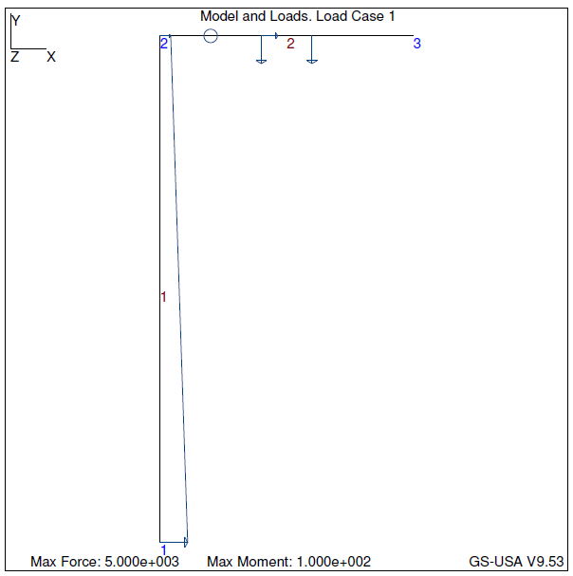

Test Case 4 – Input

|  |
| --- |
| PROBLEM SIZE  ------------  Number of nodes : 3  Number of elements : 2  Number of Material Groups : 1  Number of Element Property Groups : 1  Length of all members : 15  Number of Effective DOF : 3  ELEMENT MATERIAL PROPERTIES  ------------------------------------------------  Element Young's Modulus Poisson's Ratio CTE  ------------------------------------------------  1 2e+011 0.3 1.2e-005  2 2e+011 0.3 1.2e-005  ELEMENT CROSS-SECTIONAL PROPERTIES  -------------------------------------------------------------------------------------  Element Type Area Moment of Inertia Shear Factor Section Modulus  -------------------------------------------------------------------------------------  1 Rectangular Solid 1.5 0.125 1 0.25  2 Rectangular Solid 1.5 0.125 1 0.25  NODAL INFORMATION: COORDINATES  ---------------------------------------  Node X-Coordinate Y-Coordinate  ---------------------------------------  1 0 0  2 0 10  3 5 10  NODAL INFORMATION: FIXITIES  -------------------------------------------------------------------------------------------  Node X-Fixity X-Disp Y-Fixity Y-Disp Z-Fixity Z-Rot  -------------------------------------------------------------------------------------------  1 Specified 0 Specified 0 Specified 0  2 Free Free Free  3 Specified 0 Specified 0 Specified 0  ELEMENT INFORMATION  ----------------------------------------------  Element Start Node End Node Length  ----------------------------------------------  1 2 1 10  2 3 2 5  NODAL LOADS  ------------------------------------------  Node X-Force Y-Force Z-Moment  ------------------------------------------  ELEMENT CONCENTRATED LOADS  -----------------------------------------------------------------  Element Load Type Dist from Start Node Load Intensity  -----------------------------------------------------------------  2 LOCAL Y 3 -5000  2 LOCAL Y 2 -5000  2 LOCAL X 2 3000  2 MOMENT 1 100  ELEMENT DISTRIBUTED LOADS  -----------------------------------------------------------------  Element Load Type Int at Start Node Int at End Node  -----------------------------------------------------------------  1 LOCAL Y -5000 -2000 |

Test Case 4 – Output

|  |
| --- |
| ====================== FE RESULTS ======================  NODAL DISPLACEMENTS  --------------------------------------------------------  Node X-Displacement Y-Displacement Z-Rotation  --------------------------------------------------------  1 0 0 0  2 -2.91132e-007 -2.91132e-007 7.35581e-007  3 0 0 0  ELEMENT NODAL FORCES  --------------------------------------------------------  Element Axial Force Shear Force Bending Moment  --------------------------------------------------------  1 8733.97 21679 35722.6  -8733.97 13321 -18932.8  2 13321 8733.97 18932.8  -16321 1266.03 -362.982  MAX MEMBER STRESSES  -------------------------------------------------------------  Element Compressive Stress Tensile Stress Shear Stress  -------------------------------------------------------------  1 148713 137068 21679  2 84612 66850.6 8733.97  NODAL REACTIONS  ----------------------------------------------  Node X-Reaction Y-Reaction Z-Reaction  ----------------------------------------------  1 -21679 8733.97 35722.6  2  3 -16321 1266.03 -362.982  Absolute Error Norm: 1.81899e-012  Relative Error Norm: 6.78219e-017 |

|  |  |  |  |  |  |  |
| --- | --- | --- | --- | --- | --- | --- |
| Test Case 4 – Stress Results [Pa] | My Frame© | | | GS-USA© | | |
| Element | Compressive Stress | Tensile Stress | Shear Stress | Compressive Stress | Tensile Stress | Shear Stress |
| 1 | 148713 | 137068 | 21679 | 148713 | 137068 | 21679 |
| 2 | 84612 | 66850.6 | 8733.97 | 84612 | 66850.6 | 8733.97 |

|  |  |  |  |  |  |  |
| --- | --- | --- | --- | --- | --- | --- |
| Test Case 4 – Equilibrium Results [N] | My Frame©change me | | | GS-USA© | | |
| Node | X-Reaction | Y-Reaction | Z-Reaction | X-Reaction | Y-Reaction | Z-Reaction |
| 1 | -21679 | 8733.97 | 35722.6 | -21679 | 8733.97 | 35722.6 |
| 3 | -16321 | 1266.03 | -362.982 | -16321 | 1266.03 | -362.982 |

## Test Case 5

*UNITS [N, m]*

Taking the same model from test case 4, we can complicate the analysis by introducing an additional distributed load as well as a concentrated load along element 1. The model is as shown below.

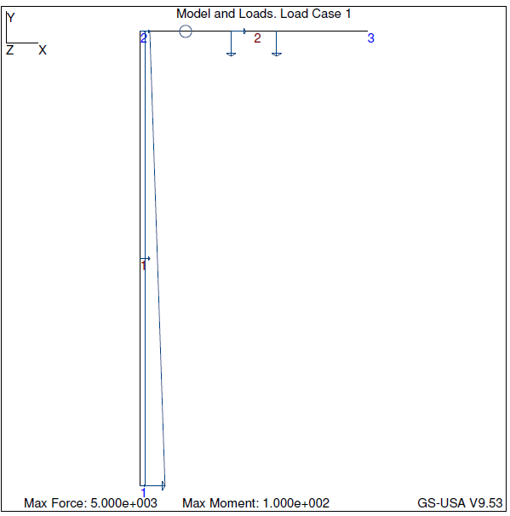

Test Case 5 – Input

|  |
| --- |
| PROBLEM SIZE  ------------  Number of nodes : 3  Number of elements : 2  Number of Material Groups : 1  Number of Element Property Groups : 1  Length of all members : 15  Number of Effective DOF : 3  ELEMENT MATERIAL PROPERTIES  ------------------------------------------------  Element Young's Modulus Poisson's Ratio CTE  ------------------------------------------------  1 2e+011 0.3 1.2e-005  2 2e+011 0.3 1.2e-005  ELEMENT CROSS-SECTIONAL PROPERTIES  -------------------------------------------------------------------------------------  Element Type Area Moment of Inertia Shear Factor Section Modulus  -------------------------------------------------------------------------------------  1 Rectangular Solid 1.5 0.125 1 0.25  2 Rectangular Solid 1.5 0.125 1 0.25  NODAL INFORMATION: COORDINATES  ---------------------------------------  Node X-Coordinate Y-Coordinate  ---------------------------------------  1 0 0  2 0 10  3 5 10  NODAL INFORMATION: FIXITIES  -------------------------------------------------------------------------------------------  Node X-Fixity X-Disp Y-Fixity Y-Disp Z-Fixity Z-Rot  -------------------------------------------------------------------------------------------  1 Specified 0 Specified 0 Specified 0  2 Free Free Free  3 Specified 0 Specified 0 Specified 0  ELEMENT INFORMATION  ----------------------------------------------  Element Start Node End Node Length  ----------------------------------------------  1 2 1 10  2 3 2 5  NODAL LOADS  ------------------------------------------  Node X-Force Y-Force Z-Moment  ------------------------------------------  ELEMENT CONCENTRATED LOADS  -----------------------------------------------------------------  Element Load Type Dist from Start Node Load Intensity  -----------------------------------------------------------------  1 LOCAL Y 5 -2000  2 LOCAL Y 3 -5000  2 LOCAL Y 2 -5000  2 LOCAL X 2 3000  2 MOMENT 1 100  ELEMENT DISTRIBUTED LOADS  -----------------------------------------------------------------  Element Load Type Int at Start Node Int at End Node  -----------------------------------------------------------------  1 LOCAL Y -5000 -2000  1 LOCAL Y -1000 -1000 |

Test Case 5 – Output

|  |
| --- |
| ====================== FE RESULTS ======================  NODAL DISPLACEMENTS  --------------------------------------------------------  Node X-Displacement Y-Displacement Z-Rotation  --------------------------------------------------------  1 0 0 0  2 -3.59709e-007 -3.59709e-007 1.10589e-006  3 0 0 0  ELEMENT NODAL FORCES  --------------------------------------------------------  Element Axial Force Shear Force Bending Moment  --------------------------------------------------------  1 10791.3 28261.5 48542.9  -10791.3 18738.5 -25927.6  2 18738.5 10791.3 25927.6  -21738.5 -791.257 2928.68  MAX MEMBER STRESSES  -------------------------------------------------------------  Element Compressive Stress Tensile Stress Shear Stress  -------------------------------------------------------------  1 201366 186978 28261.5  2 116203 91218.1 10791.3  NODAL REACTIONS  ----------------------------------------------  Node X-Reaction Y-Reaction Z-Reaction  ----------------------------------------------  1 -28261.5 10791.3 48542.9  2  3 -21738.5 -791.257 2928.68  Absolute Error Norm: 1.81899e-012  Relative Error Norm: 4.67061e-017 |

|  |  |  |  |  |  |  |
| --- | --- | --- | --- | --- | --- | --- |
| Test Case 5 – Stress Results [Pa] | My Frame© | | | GS-USA© | | |
| Element | Compressive Stress | Tensile Stress | Shear Stress | Compressive Stress | Tensile Stress | Shear Stress |
| 1 | 201366 | 186978 | 28261.5 | 201366 | 186978 | 28261.5 |
| 2 | 116203 | 91218.1 | 10791.3 | 116203 | 91218.1 | 10791.3 |

|  |  |  |  |  |  |  |
| --- | --- | --- | --- | --- | --- | --- |
| Test Case 5 – Equilibrium Results [N] | My Frame© | | | GS-USA© | | |
| Node | X-Reaction | Y-Reaction | Z-Reaction | X-Reaction | Y-Reaction | Z-Reaction |
| 1 | -28261.5 | 10791.3 | 48542.9 | -28261.5 | 10791.3 | 48542.9 |
| 3 | -21738.5 | -791.257 | 2928.68 | -21738.5 | -791.257 | 2928.68 |

## Test Case 6

*UNITS [N, m]*

Taking the same model from test case 5, we can introduce a specified displacement at the nodes. For this case, we will specify a rotation at node 1 and an x displacement at node 2. The results are shown below.

Test Case 6 – Input

|  |
| --- |
| PROBLEM SIZE  ------------  Number of nodes : 3  Number of elements : 2  Number of Material Groups : 2  Number of Element Property Groups : 2  Length of all members : 15  Number of Effective DOF : 2  ELEMENT MATERIAL PROPERTIES  ------------------------------------------------  Element Young's Modulus Poisson's Ratio CTE  ------------------------------------------------  1 4e+010 0.3 1.1e-005  2 2.2e+010 0.3 1.1e-005  ELEMENT CROSS-SECTIONAL PROPERTIES  -------------------------------------------------------------------------------------  Element Type Area Moment of Inertia Shear Factor Section Modulus  -------------------------------------------------------------------------------------  1 Rectangular Solid 1.5 0.125 1 0.25  2 Circular Solid 0.0314159 7.85398e-005 0.0235619 0.000785398  NODAL INFORMATION: COORDINATES  ---------------------------------------  Node X-Coordinate Y-Coordinate  ---------------------------------------  1 0 0  2 0 10  3 5 10  NODAL INFORMATION: FIXITIES  -------------------------------------------------------------------------------------------  Node X-Fixity X-Disp Y-Fixity Y-Disp Z-Fixity Z-Rot  -------------------------------------------------------------------------------------------  1 Specified 0 Specified 0 Specified -0.001  2 Specified 0.005 Free Free  3 Specified 0 Specified 0 Specified 0  ELEMENT INFORMATION  ----------------------------------------------  Element Start Node End Node Length  ----------------------------------------------  1 2 1 10  2 3 2 5  NODAL LOADS  ------------------------------------------  Node X-Force Y-Force Z-Moment  ------------------------------------------  2 0 -10000 -100  ELEMENT CONCENTRATED LOADS  -----------------------------------------------------------------  Element Load Type Dist from Start Node Load Intensity  -----------------------------------------------------------------  1 LOCAL Y 5 -2000  2 LOCAL Y 3 -5000  2 LOCAL Y 2 -5000  2 LOCAL X 2 3000  2 MOMENT 1 100  ELEMENT DISTRIBUTED LOADS  -----------------------------------------------------------------  Element Load Type Int at Start Node Int at End Node  -----------------------------------------------------------------  1 LOCAL Y -5000 -2000  1 LOCAL Y -1000 -1000 |

Test Case 6 – Output

|  |
| --- |
| ====================== FE RESULTS ======================  NODAL DISPLACEMENTS  --------------------------------------------------------  Node X-Displacement Y-Displacement Z-Rotation  --------------------------------------------------------  1 0 0 -0.001  2 0.005 -2.48695e-006 -0.000234122  3 0 0 0  ELEMENT NODAL FORCES  --------------------------------------------------------  Element Axial Force Shear Force Bending Moment  --------------------------------------------------------  1 14921.7 -43736.5 -691622  -14921.7 90736.5 -5743.34  2 689350 4921.7 5643.34  -692350 5078.3 -6134.84  MAX MEMBER STRESSES  -------------------------------------------------------------  Element Compressive Stress Tensile Stress Shear Stress  -------------------------------------------------------------  1 2.77643e+006 2.75654e+006 90736.5  2 2.98493e+007 0 215530  NODAL REACTIONS  ----------------------------------------------  Node X-Reaction Y-Reaction Z-Reaction  ----------------------------------------------  1 43736.5 14921.7 -691622  2 598614  3 -692350 5078.3 -6134.84  Absolute Error Norm: 0  Relative Error Norm: 0 |

|  |  |  |  |  |  |  |
| --- | --- | --- | --- | --- | --- | --- |
| Test Case 6 – Stress Results [Pa] | My Frame© | | | GS-USA© | | |
| Element | Compressive Stress | Tensile Stress | Shear Stress | Compressive Stress | Tensile Stress | Shear Stress |
| 1 | 2.77643e6 | 2.75654e6 | 90736.5 | 2.77624e6 | 2.75634e6 | 90721.5 |
| 2 | 2.98493e7 | 0 | 215530 | 2.98493e7 | 0 | 215529 |

|  |  |  |  |  |  |  |
| --- | --- | --- | --- | --- | --- | --- |
| Test Case 6 – Equilibrium Results [N] | My Frame© | | | GS-USA© | | |
| Node | X-Reaction | Y-Reaction | Z-Reaction | X-Reaction | Y-Reaction | Z-Reaction |
| 1 | 43736.5 | 14921.7 | -691622 | 43721.5 | 14921.7 | -691572 |
| 2 | 598614 | 0 | 0 | 598629 | 0 | 0 |
| 3 | -692350 | 5078.3 | -6134.84 | -692350 | 5078.3 | -6134.84 |

Some slight error was found here between the program and GS-USA. This can be contributed to the minimal accuracy in the floating point values as opposed to double precision, which GS-USA most likely uses for these computations. The values with lower significant figures are more accurate than those with higher significant figures, which is a testament to the differences in accuracy between float and double.

## Test Case 7

*UNITS [N, m]*

Using the same frame model as previously shown, we can again complicate the analysis by adding a nodal load at the second node, and changing the material type between the two elements. Additionally, we will change the cross-sections for each element. Below are the input and results files for the new test case as shown below.

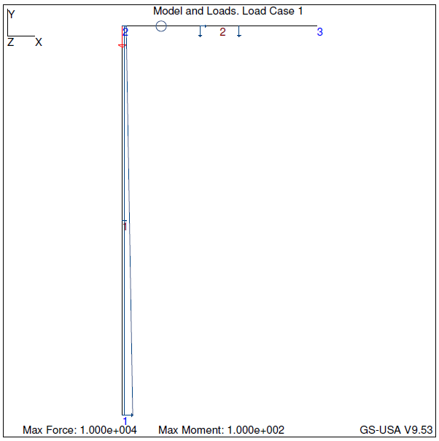

Test Case 7 – Input

|  |
| --- |
| PROBLEM SIZE  ------------  Number of nodes : 3  Number of elements : 2  Number of Material Groups : 2  Number of Element Property Groups : 2  Length of all members : 15  Number of Effective DOF : 3  ELEMENT MATERIAL PROPERTIES  ------------------------------------------------  Element Young's Modulus Poisson's Ratio CTE  ------------------------------------------------  1 4e+010 0.3 1.1e-005  2 2.2e+010 0.3 1.1e-005  ELEMENT CROSS-SECTIONAL PROPERTIES  -------------------------------------------------------------------------------------  Element Type Area Moment of Inertia Shear Factor Section Modulus  -------------------------------------------------------------------------------------  1 Rectangular Solid 1.5 0.125 1 0.25  2 Circular Solid 0.0314159 7.85398e-005 0.0235619 0.000785398  NODAL INFORMATION: COORDINATES  ---------------------------------------  Node X-Coordinate Y-Coordinate  ---------------------------------------  1 0 0  2 0 10  3 5 10  NODAL INFORMATION: FIXITIES  -------------------------------------------------------------------------------------------  Node X-Fixity X-Disp Y-Fixity Y-Disp Z-Fixity Z-Rot  -------------------------------------------------------------------------------------------  1 Specified 0 Specified 0 Specified 0  2 Free Free Free  3 Specified 0 Specified 0 Specified 0  ELEMENT INFORMATION  ----------------------------------------------  Element Start Node End Node Length  ----------------------------------------------  1 2 1 10  2 3 2 5  NODAL LOADS  ------------------------------------------  Node X-Force Y-Force Z-Moment  ------------------------------------------  2 0 -10000 0  ELEMENT CONCENTRATED LOADS  -----------------------------------------------------------------  Element Load Type Dist from Start Node Load Intensity  -----------------------------------------------------------------  1 LOCAL Y 5 -2000  2 LOCAL Y 3 -5000  2 LOCAL Y 2 -5000  2 LOCAL X 2 3000  2 MOMENT 1 100  ELEMENT DISTRIBUTED LOADS  -----------------------------------------------------------------  Element Load Type Int at Start Node Int at End Node  -----------------------------------------------------------------  1 LOCAL Y -5000 -2000  1 LOCAL Y -1000 -1000 |

Test Case 7 – Output

|  |
| --- |
| ====================== FE RESULTS ======================  NODAL DISPLACEMENTS  --------------------------------------------------------  Node X-Displacement Y-Displacement Z-Rotation  --------------------------------------------------------  1 0 0 0  2 0.000114663 -2.50303e-006 -1.43187e-006  3 0 0 0  ELEMENT NODAL FORCES  --------------------------------------------------------  Element Axial Force Shear Force Bending Moment  --------------------------------------------------------  1 15018.2 32950.2 75466.9  -15018.2 14049.8 -5964.98  2 14049.8 5018.19 5964.98  -17049.8 4981.81 -5974.03  MAX MEMBER STRESSES  -------------------------------------------------------------  Element Compressive Stress Tensile Stress Shear Stress  -------------------------------------------------------------  1 311880 291855 32950.2  2 8.14908e+006 7.14763e+006 212979  NODAL REACTIONS  ----------------------------------------------  Node X-Reaction Y-Reaction Z-Reaction  ----------------------------------------------  1 -32950.2 15018.2 75466.9  2  3 -17049.8 4981.81 -5974.03  Absolute Error Norm: 8.13477e-012  Relative Error Norm: 1.9631e-016 |

|  |  |  |  |  |  |  |
| --- | --- | --- | --- | --- | --- | --- |
| Test Case 7 – Stress Results [Pa] | My Frame© | | | GS-USA© | | |
| Element | Compressive Stress | Tensile Stress | Shear Stress | Compressive Stress | Tensile Stress | Shear Stress |
| 1 | 311880 | 291855 | 32950.2 | 311880 | 291855 | 32950.2 |
| 2 | 8.14908e6 | 7.14763e6 | 212979 | 8.14908e6 | 7.14763e6 | 212979 |

|  |  |  |  |  |  |  |
| --- | --- | --- | --- | --- | --- | --- |
| Test Case 7 – Equilibrium Results [N] | My Frame© | | | GS-USA© | | |
| Node | X-Reaction | Y-Reaction | Z-Reaction | X-Reaction | Y-Reaction | Z-Reaction |
| 1 | -32950.2 | 15018.2 | 75466.9 | -32950.2 | 15018.2 | 75466.9 |
| 3 | -17049.8 | 4981.81 | -5974.03 | -17049.8 | 4981.81 | -5974.03 |

## Test Case 8

*UNITS [lb, in]*

We can create a model of a column-roof truss structure as shown below. Using different cross-sections for the columns and truss, applying distributed loads along the elements and a nodal load at the top of the column, we have,

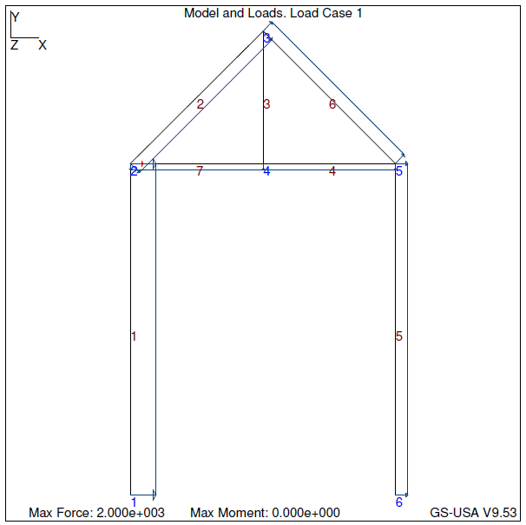

Test Case 8 – Input

|  |
| --- |
| PROBLEM SIZE  ------------  Number of nodes : 6  Number of elements : 7  Number of Material Groups : 1  Number of Element Property Groups : 2  Length of all members : 519.765  Number of Effective DOF : 12  ELEMENT MATERIAL PROPERTIES  ------------------------------------------------  Element Young's Modulus Poisson's Ratio CTE  ------------------------------------------------  1 2e+011 0.3 1.2e-005  2 2e+011 0.3 1.2e-005  3 2e+011 0.3 1.2e-005  4 2e+011 0.3 1.2e-005  5 2e+011 0.3 1.2e-005  6 2e+011 0.3 1.2e-005  7 2e+011 0.3 1.2e-005  ELEMENT CROSS-SECTIONAL PROPERTIES  -------------------------------------------------------------------------------------  Element Type Area Moment of Inertia Shear Factor Section Modulus  -------------------------------------------------------------------------------------  1 Rectangular Solid 72 864 48 144  2 Rectangular Solid 24 72 16 24  3 Rectangular Solid 24 72 16 24  4 Rectangular Solid 24 72 16 24  5 Rectangular Solid 72 864 48 144  6 Rectangular Solid 24 72 16 24  7 Rectangular Solid 24 72 16 24  NODAL INFORMATION: COORDINATES  ---------------------------------------  Node X-Coordinate Y-Coordinate  ---------------------------------------  1 0 0  2 0 120  3 48 168  4 48 120  5 96 120  6 96 0  NODAL INFORMATION: FIXITIES  -------------------------------------------------------------------------------------------  Node X-Fixity X-Disp Y-Fixity Y-Disp Z-Fixity Z-Rot  -------------------------------------------------------------------------------------------  1 Specified 0 Specified 0 Specified 0  2 Free Free Free  3 Free Free Free  4 Free Free Free  5 Free Free Free  6 Specified 0 Specified 0 Specified 0  ELEMENT INFORMATION  ----------------------------------------------  Element Start Node End Node Length  ----------------------------------------------  1 2 1 120  2 3 2 67.8822  3 4 3 48  4 5 4 48  5 6 5 120  6 5 3 67.8822  7 4 2 48  NODAL LOADS  ------------------------------------------  Node X-Force Y-Force Z-Moment  ------------------------------------------  2 1000 0 0  ELEMENT CONCENTRATED LOADS  -----------------------------------------------------------------  Element Load Type Dist from Start Node Load Intensity  -----------------------------------------------------------------  ELEMENT DISTRIBUTED LOADS  -----------------------------------------------------------------  Element Load Type Int at Start Node Int at End Node  -----------------------------------------------------------------  1 LOCAL Y -2000 -2000  2 LOCAL Y -1000 -1000  4 LOCAL Y -500 -500  5 LOCAL Y 1000 1000  6 LOCAL Y 1000 1000  7 LOCAL Y -500 -500 |

Test Case 8 – Output

|  |
| --- |
| ====================== FE RESULTS ======================  NODAL DISPLACEMENTS  --------------------------------------------------------  Node X-Displacement Y-Displacement Z-Rotation  --------------------------------------------------------  1 0 0 0  2 0.00024644 3.85034e-007 -2.1188e-006  3 0.000247316 -2.59589e-007 7.58305e-007  4 0.000246516 -4.45491e-007 5.79996e-007  5 0.000246078 -7.85034e-007 -2.2426e-006  6 0 0 0  ELEMENT NODAL FORCES  --------------------------------------------------------  Element Axial Force Shear Force Bending Moment  --------------------------------------------------------  1 -46204.1 263174 1.40415e+007  46204.1 -23174.3 3.13939e+006  2 -11566.9 9025.89 -1.07198e+006  11566.9 58856.4 -619326  3 -18590.1 51436 1.28796e+006  18590.1 -51436 1.18097e+006  4 43823 -49817.2 -540833  -43823 73817.2 -2.42639e+006  5 94204.1 73825.8 3.6002e+006  -94204.1 -193826 1.24589e+007  6 35630.8 -61082.8 -668631  -35630.8 -6799.43 -1.17381e+006  7 -7612.98 -44407.3 -2.06741e+006  7612.98 68407.3 -640138  MAX MEMBER STRESSES  -------------------------------------------------------------  Element Compressive Stress Tensile Stress Shear Stress  -------------------------------------------------------------  1 96868.8 98152.3 5482.8  2 45880.1 46844 3678.52  3 52890.3 54439.5 3214.75  4 102926 99273.7 4613.57  5 87828.5 85211.7 4038.04  6 51356.4 48387.2 3817.68  7 85825 86459.4 4275.46  NODAL REACTIONS  ----------------------------------------------  Node X-Reaction Y-Reaction Z-Reaction  ----------------------------------------------  1 -263174 -46204.1 1.40415e+007  2  3  4  5  6 -193826 94204.1 1.24589e+007  Absolute Error Norm: 1.28735e-008  Relative Error Norm: 5.67803e-015 |

|  |  |  |  |  |  |  |
| --- | --- | --- | --- | --- | --- | --- |
| Test Case 8 – Stress Results [psi] | My Frame© | | | GS-USA© | | |
| Element | Compressive Stress | Tensile Stress | Shear Stress | Compressive Stress | Tensile Stress | Shear Stress |
| 1 | 96868.8 | 98152.3 | 5482.8 | 96868.8 | 98152.3 | 5482.8 |
| 2 | 45880.1 | 46844 | 3678.52 | 45871.5 | 46835.5 | 3678.52 |
| 3 | 52890.3 | 54439.5 | 3214.75 | 52890.3 | 54439.5 | 3214.75 |
| 4 | 102926 | 99273.7 | 4613.57 | 102926 | 99273.7 | 4613.57 |
| 5 | 87828.5 | 85211.7 | 4038.04 | 87828.5 | 85211.7 | 4038.04 |
| 6 | 51356.4 | 48387.2 | 3817.68 | 51356.1 | 48386.9 | 3817.68 |
| 7 | 85825 | 86459.4 | 4275.46 | 85825 | 86459.4 | 4275.46 |

|  |  |  |  |  |  |  |
| --- | --- | --- | --- | --- | --- | --- |
| Test Case 8 – Equilibrium Results [lb] | My Frame© | | | GS-USA© | | |
| Node | X-Reaction | Y-Reaction | Z-Reaction | X-Reaction | Y-Reaction | Z-Reaction |
| 1 | -263174 | -46204.1 | 1.40415e7 | -263174 | -46204 | 1.40415e7 |
| 6 | -193826 | 94204.1 | 1.24589e7 | -193826 | 94204 | 1.24589e7 |

We can see with this result that the values are almost exact! The result could be more exact if additional cuts along the beam are taken (current cut amount at 100) and if the use of double precious was present for every computation.